Lab 3:

**Authenticate**

The platform/ingest/v1/events uses access token authentication. To generate an access token

1. Go to Access Tokens.
2. Select Generate new token.
3. Enter a token name.
4. Find and select the OpenPipeline – Ingest Events (openpipeline.events) scope.

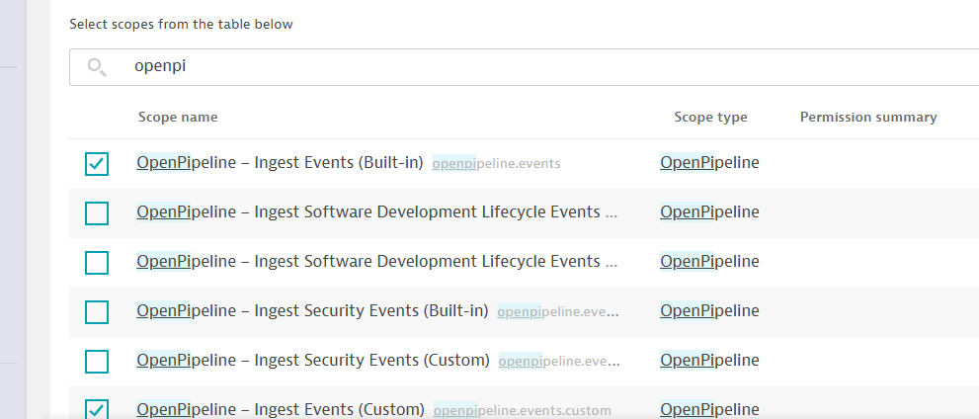

1. Select Generate token.
2. Select Copy and then paste the token to a secure location. It's a long string that you need to copy and paste back into Dynatrace later.

**Copy the endpoint path**

1. Go to OpenPipeline  > Events > Ingest sources.
2. Find the ingest source you are interested in.
3. In the Endpoints path column, select the endpoint name >  Copy.

**Send an event**

Run the following sample command to send an event to your environment endpoint platform/ingest/v1/events via POST request.

* Use postman